Task 3

3a)

CREATE TABLE `album` (   `album_id` int(50) NOT NULL,   `album_name` varchar(50) DEFAULT NULL,   `album_desc` varchar(50),   `rating` varchar(45) DEFAULT NULL,   PRIMARY KEY (`album_id`) );

CREATE TABLE `artist` (   `artist_id` int(50) NOT NULL,   `artist_name` varchar(50) DEFAULT NULL,   PRIMARY KEY (`artist_id`) ) ;

CREATE TABLE `genre` (   `genre_id` int(50) NOT NULL,   `genre` varchar(50),   `genre_desc` varchar(50) DEFAULT NULL,   PRIMARY KEY (`genre_id`) );

CREATE TABLE `album_artist` (

`album_id` int(50) NOT NULL DEFAULT '0',

`artist_id` int(50) NOT NULL DEFAULT '0',

PRIMARY KEY (`album_id`,`artist_id`),

CONSTRAINT FOREIGN KEY (`album_id`) REFERENCES `album` (`album_id`),

CONSTRAINT FOREIGN KEY (`artist_id`) REFERENCES `artist` (`artist_id`)

) ;

CREATE TABLE `album_genre` (

`album_id` int(50) NOT NULL DEFAULT '0',

`genre_id` int(50) NOT NULL DEFAULT '0',

PRIMARY KEY (`album_id`,`genre_id`),

CONSTRAINT `album_genre_ibfk_1` FOREIGN KEY (`album_id`) REFERENCES `album` (`album_id`),

CONSTRAINT `album_genre_ibfk_2` FOREIGN KEY (`genre_id`) REFERENCES `genre` (`genre_id`)

) ;

CREATE TABLE `my_collection` (

`my_id` int(50) NOT NULL DEFAULT '0',

`album_id` int(50) NOT NULL DEFAULT '0',

`duration` int(50),

`number_of_tracks` varchar(50),

`disktype` varchar(50),

`album_type` varchar(50),

`alcond` varchar(50),

`recorddate` varchar(50),

`releasedate` varchar(50) DEFAULT NULL,

`price` varchar(50) DEFAULT NULL,

`purchase_date` varchar(50) DEFAULT NULL,

`numberofcopies` int(50) DEFAULT NULL,

PRIMARY KEY (`my_id`,`album_id`),

CONSTRAINT ` FOREIGN KEY (`album_id`) REFERENCES `album` (`album_id`)

) ;

3b)

**Album:**

INSERT INTO `album` (`album_id`,`album_name`,`album_desc`,`rating`) VALUES (1,'Master of puppets','favorite','5');

INSERT INTO `album` (`album_id`,`album_name`,`album_desc`,`rating`) VALUES (2,'Load','another brick in the wall','5');

INSERT INTO `album` (`album_id`,`album_name`,`album_desc`,`rating`) VALUES (3,'Mall','parkit','3');

INSERT INTO `album` (`album_id`,`album_name`,`album_desc`,`rating`) VALUES (4,'Slumdog','BGM','2');

INSERT INTO `album` (`album_id`,`album_name`,`album_desc`,`rating`) VALUES (5,'back in black','highway to hell','2');

INSERT INTO `album` (`album_id`,`album_name`,`album_desc`,`rating`) VALUES (6,'Powerslave','favorite','1');

INSERT INTO `album` (`album_id`,`album_name`,`album_desc`,`rating`) VALUES (7,'Roja','ARR','4');

INSERT INTO `album` (`album_id`,`album_name`,`album_desc`,`rating`) VALUES (8,'Death Magnetic','Rock','5');

INSERT INTO `album` (`album_id`,`album_name`,`album_desc`,`rating`) VALUES (9,'Ride the lightening','awesome','3');

INSERT INTO `album` (`album_id`,`album_name`,`album_desc`,`rating`) VALUES (10,'another brick in the wall','no education','4');

**Artist:**

INSERT INTO `artist` (`artist_id`,`artist_name`) VALUES (1,'Metallica');

INSERT INTO `artist` (`artist_id`,`artist_name`) VALUES (2,'pink floyd');

INSERT INTO `artist` (`artist_id`,`artist_name`) VALUES (3,'linkin park');

INSERT INTO `artist` (`artist_id`,`artist_name`) VALUES (4,'Slumdog');

INSERT INTO `artist` (`artist_id`,`artist_name`) VALUES (5,'acdc');

INSERT INTO `artist` (`artist_id`,`artist_name`) VALUES (6,NULL);

INSERT INTO `artist` (`artist_id`,`artist_name`) VALUES (7,NULL);

INSERT INTO `artist` (`artist_id`,`artist_name`) VALUES (8,'ARR');

INSERT INTO `artist` (`artist_id`,`artist_name`) VALUES (9,NULL);

INSERT INTO `artist` (`artist_id`,`artist_name`) VALUES (10,'Iron Maiden');

**Genre:**

INSERT INTO `genre` (`genre_id`,`genre`,`genre_desc`) VALUES (1,'hard rock','headbang');

INSERT INTO `genre` (`genre_id`,`genre`,`genre_desc`) VALUES (2,'pop','have fun');

INSERT INTO `genre` (`genre_id`,`genre`,`genre_desc`) VALUES (3,'metal','listen');

INSERT INTO `genre` (`genre_id`,`genre`,`genre_desc`) VALUES (4,'classical','rythym');

INSERT INTO `genre` (`genre_id`,`genre`,`genre_desc`) VALUES (5,'country','normal');

INSERT INTO `genre` (`genre_id`,`genre`,`genre_desc`) VALUES (6,'techno','dj');

**Album_genre:**

INSERT INTO `album_genre` (`album_id`,`genre_id`) VALUES (1,1);

INSERT INTO `album_genre` (`album_id`,`genre_id`) VALUES (6,1);

INSERT INTO `album_genre` (`album_id`,`genre_id`) VALUES (3,2);

INSERT INTO `album_genre` (`album_id`,`genre_id`) VALUES (8,2);

INSERT INTO `album_genre` (`album_id`,`genre_id`) VALUES (2,3);

INSERT INTO `album_genre` (`album_id`,`genre_id`) VALUES (5,3);

INSERT INTO `album_genre` (`album_id`,`genre_id`) VALUES (10,3);

INSERT INTO `album_genre` (`album_id`,`genre_id`) VALUES (4,4);

INSERT INTO `album_genre` (`album_id`,`genre_id`) VALUES (7,4);

INSERT INTO `album_genre` (`album_id`,`genre_id`) VALUES (4,5);

INSERT INTO `album_genre` (`album_id`,`genre_id`) VALUES (7,5);

INSERT INTO `album_genre` (`album_id`,`genre_id`) VALUES (9,5);

INSERT INTO `album_genre` (`album_id`,`genre_id`) VALUES (5,6);

**Album_artist:**

INSERT INTO `album_artist` (`album_id`,`artist_id`) VALUES (1,1);

INSERT INTO `album_artist` (`album_id`,`artist_id`) VALUES (8,1);

INSERT INTO `album_artist` (`album_id`,`artist_id`) VALUES (1,2);

INSERT INTO `album_artist` (`album_id`,`artist_id`) VALUES (2,2);

INSERT INTO `album_artist` (`album_id`,`artist_id`) VALUES (9,2);

INSERT INTO `album_artist` (`album_id`,`artist_id`) VALUES (10,2);

INSERT INTO `album_artist` (`album_id`,`artist_id`) VALUES (3,3);

INSERT INTO `album_artist` (`album_id`,`artist_id`) VALUES (2,4);

INSERT INTO `album_artist` (`album_id`,`artist_id`) VALUES (7,4);

INSERT INTO `album_artist` (`album_id`,`artist_id`) VALUES (3,6);

INSERT INTO `album_artist` (`album_id`,`artist_id`) VALUES (5,7);

INSERT INTO `album_artist` (`album_id`,`artist_id`) VALUES (2,8);

INSERT INTO `album_artist` (`album_id`,`artist_id`) VALUES (4,8);

INSERT INTO `album_artist` (`album_id`,`artist_id`) VALUES (5,8);

INSERT INTO `album_artist` (`album_id`,`artist_id`) VALUES (5,9);

INSERT INTO `album_artist` (`album_id`,`artist_id`) VALUES (6,9);

INSERT INTO `album_artist` (`album_id`,`artist_id`) VALUES (5,10);

INSERT INTO `album_artist` (`album_id`,`artist_id`) VALUES (6,10);

**My_Collection:**

INSERT INTO `my_collection` (`my_id`,`album_id`,`duration`,`number_of_tracks`,`disktype`,`album_type`,`alcond`,`recorddate`,`releasedate`,`price`,`purchase_date`,`numberofcopies`,`classic`) VALUES (1,1,1510,'5','vinyl','band','good','12-1-1988','2-2-1990','20','1-10-1995',1,'1');

INSERT INTO `my_collection` (`my_id`,`album_id`,`duration`,`number_of_tracks`,`disktype`,`album_type`,`alcond`,`recorddate`,`releasedate`,`price`,`purchase_date`,`numberofcopies`,`classic`) VALUES (2,1,460,'2','Vinyl','Band','Mint','1-11-985','2-3-1988','25','10-12-1994',2,'1');

INSERT INTO `my_collection` (`my_id`,`album_id`,`duration`,`number_of_tracks`,`disktype`,`album_type`,`alcond`,`recorddate`,`releasedate`,`price`,`purchase_date`,`numberofcopies`,`classic`) VALUES (3,10,1410,'10','vinyl','Compilation','Mint','10-5-1988','2-4-2000','23','8-8-1990',1,'1');

INSERT INTO `my_collection` (`my_id`,`album_id`,`duration`,`number_of_tracks`,`disktype`,`album_type`,`alcond`,`recorddate`,`releasedate`,`price`,`purchase_date`,`numberofcopies`,`classic`) VALUES (4,7,2010,'10','Vinyl','Compilation','mint','5-10-1991','10-5-1995','15',NULL,4,'0');

INSERT INTO `my_collection` (`my_id`,`album_id`,`duration`,`number_of_tracks`,`disktype`,`album_type`,`alcond`,`recorddate`,`releasedate`,`price`,`purchase_date`,`numberofcopies`,`classic`) VALUES (5,9,440,'1','CD','single','good','1-12-2012',NULL,'30','9-10-2015',3,'1');

INSERT INTO `my_collection` (`my_id`,`album_id`,`duration`,`number_of_tracks`,`disktype`,`album_type`,`alcond`,`recorddate`,`releasedate`,`price`,`purchase_date`,`numberofcopies`,`classic`) VALUES (6,10,1410,'2','Vinyl','Band','poor','2-3-2015','10-10-2015','0.5',NULL,5,'0');

INSERT INTO `my_collection` (`my_id`,`album_id`,`duration`,`number_of_tracks`,`disktype`,`album_type`,`alcond`,`recorddate`,`releasedate`,`price`,`purchase_date`,`numberofcopies`,`classic`) VALUES (7,6,440,'1','cd','single','Mint','20-12-1976','5-5-1980','12','11-12-1988',4,'0');

INSERT INTO `my_collection` (`my_id`,`album_id`,`duration`,`number_of_tracks`,`disktype`,`album_type`,`alcond`,`recorddate`,`releasedate`,`price`,`purchase_date`,`numberofcopies`,`classic`) VALUES (8,7,440,'1','cd','single','acceptable','1-5-1976','6-6-1980','10','12-11-1984',5,'1');

INSERT INTO `my_collection` (`my_id`,`album_id`,`duration`,`number_of_tracks`,`disktype`,`album_type`,`alcond`,`recorddate`,`releasedate`,`price`,`purchase_date`,`numberofcopies`,`classic`) VALUES (9,5,540,'1','CD','single','mint','5-5-200','10-6-2002','10','8-5-2003',4,'0');

INSERT INTO `my_collection` (`my_id`,`album_id`,`duration`,`number_of_tracks`,`disktype`,`album_type`,`alcond`,`recorddate`,`releasedate`,`price`,`purchase_date`,`numberofcopies`,`classic`) VALUES (10,2,480,'1','CD','Band','acceptable','4-10-2003','11-7-2004','10','7-7-2005',1,'0');

INSERT INTO `my_collection` (`my_id`,`album_id`,`duration`,`number_of_tracks`,`disktype`,`album_type`,`alcond`,`recorddate`,`releasedate`,`price`,`purchase_date`,`numberofcopies`,`classic`) VALUES (11,3,1200,'4','Vinyl','Compilation','Poor','6-10-1949','8-10-1922','17','7-5-2001',2,'0');

INSERT INTO `my_collection` (`my_id`,`album_id`,`duration`,`number_of_tracks`,`disktype`,`album_type`,`alcond`,`recorddate`,`releasedate`,`price`,`purchase_date`,`numberofcopies`,`classic`) VALUES (12,4,1530,'5','CD','Compilation','Good','6-11-1927','8-8-1949','30','5-9-1992',4,'0');

INSERT INTO `my_collection` (`my_id`,`album_id`,`duration`,`number_of_tracks`,`disktype`,`album_type`,`alcond`,`recorddate`,`releasedate`,`price`,`purchase_date`,`numberofcopies`,`classic`) VALUES (13,8,1000,'3','Vinyl','Compilation','poor','10-11-1998','10-9-1998','0.2','7-11-1998',5,'1');

INSERT INTO `my_collection` (`my_id`,`album_id`,`duration`,`number_of_tracks`,`disktype`,`album_type`,`alcond`,`recorddate`,`releasedate`,`price`,`purchase_date`,`numberofcopies`,`classic`) VALUES (14,8,1000,'3','Vinyl','Compilation','mint','11-10-1998','8-10-1998','35','26-11-1998',4,'1');

INSERT INTO `my_collection` (`my_id`,`album_id`,`duration`,`number_of_tracks`,`disktype`,`album_type`,`alcond`,`recorddate`,`releasedate`,`price`,`purchase_date`,`numberofcopies`,`classic`) VALUES (15,2,4030,'2','CD','Single','mint','12-12-2015','10-12-2015','100','9-11-2015',5,'1');

INSERT INTO `my_collection` (`my_id`,`album_id`,`duration`,`number_of_tracks`,`disktype`,`album_type`,`alcond`,`recorddate`,`releasedate`,`price`,`purchase_date`,`numberofcopies`,`classic`) VALUES (16,2,1230,'1','cd','band','mint','1-2-2014','12-4-2014','10','20-12-2015',2,'1');

**TASK4:**

1. select album_name,album.album_id,alcond from album,my_collection where album.album_id=my_collection.album_id;

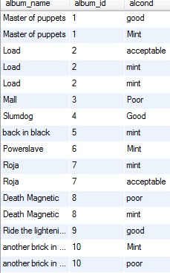

1. select count(album_id) from my_collection;

G:\2.jpg

3) select distinct album.album_id,album_name from my_collection,album where album.album_id=my_collection.album_id;

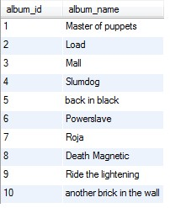

4)select

album_id,count(1) as cnt

from

my_collection

where releasedate is not null

group by album_id;

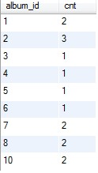

5)select sum(price) from my_collection;

G:\5.jpg

6)select

album.album_id,album_name, count(1) as cnt

from

album,

my_collection

where

album.album_id = my_collection.album_id

group by album_id

having cnt>1;

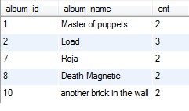

*7)select

album.album_id, artist.artist_id,artist_name,count(1) as cnt

from

album_artist,

album,

artist,

my_collection

where

album.album_id = my_collection.album_id

and artist.artist_id = album_artist.artist_id and album.album_id=album_artist.album_id

group by artist_id;

8)select album.album_id,genre.genre_id,genre,price from genre,album_genre,album,my_collection where album.album_id=my_collection.album_id and album.album_id=album_genre.album_id and genre.genre_id=album_genre.genre_id group by genre having max(price) ;

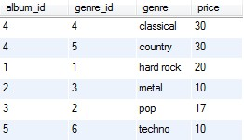

9)select album.album_id,album_name,genre,purchase_date from album,my_collection,album_genre,genre where album.album_id=my_collection.album_id and genre.genre_id=album_genre.genre_id and album.album_id=album_genre.album_id and (genre like'country' or genre like 'classical') having purchase_date>'1980';

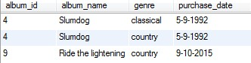

10)select

album.album_id,album_name,count(1) as cnt

from

album,

genre,

album_genre

where

album.album_id = album_genre.album_id

and genre.genre_id = album_genre.genre_id

group by album_id

having cnt>1;

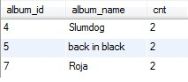

11)select

album.album_id,album_name,count(1) as cnt,album_type

from

album,

genre,

album_genre,

my_collection

where

album.album_id = album_genre.album_id

and genre.genre_id = album_genre.genre_id and album.album_id=my_collection.album_id and album_type not like'compilation'

group by album_id

having cnt>1;

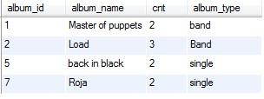

12)select album.album_id,album_name,alcond,rating,disktype from album,my_collection where album.album_id=my_collection.album_id and disktype like 'vinyl'having alcond like'mint' order by rating desc limit 5;

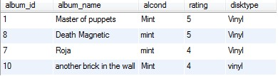

13)select avg(price),disktype from my_collection group by disktype;

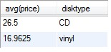

14)

*15)select price,album.album_id,album_name,alcond from album,my_collection where album.album_id=my_collection.album_id and (price=(select min(price) from my_collection)) and alcond like 'mint';

16)select count(album.album_id),album_name,recorddate from album,my_collection where album.album_id=my_collection.album_id and alcond like 'mint' group by recorddate;

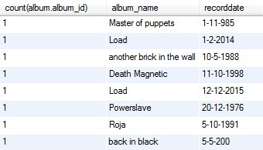

*17)select album.album_id,album_name,artist.artist_id,artist_name from my_collection,album,artist,album_artist where album.album_id=my_collection.album_id and album.album_id=album_artist.album_id and artist.artist_id=album_artist.artist_id and artist_name is null;

18)select album.album_id,artist.artist_id,album_name,artist_name from album,artist,album_artist where album.album_id=album_artist.album_id and artist.artist_id=album_artist.artist_id;

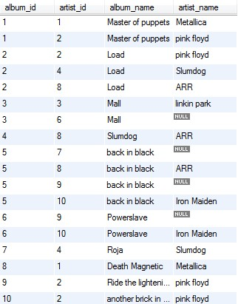

19)select

(got/total)*100 as percentage

from

(select

count(album_id) as total

from

my_collection where album_type = 'single') as t,

(select

count(album.album_id) as got

from

my_collection, album

where

album.album_id = my_collection.album_id

and album_type = 'single'

and rating > 3) as y;

G:\19.jpg

20) select cd_weight+vinyl as sum from

(select

count(disktype)*4 as CD_WEIGHT

from

my_collection

where

disktype='CD') as t,

(select

count(disktype)*9 as vinyl

from

my_collection

where

disktype='vinyl') as y;

G:\20.jpg